**HOW TO TAKE ADVANTAGE OF GAMIFICATION IN THE COLLABORATIVE ENVIRONMENT**



Suggestions on how to use the functionalities available in the INTERLINK Collaborative Environment to incentivize participation in your co-production processes.

Date: 30/05/2023

Version:V1

Licence: [CC BY-SA 4.0](https://creativecommons.org/licenses/by-sa/4.0/)

This document provides information and guidance on functionalities integrated in the INTERLINK Collaborative Environment to support recognition and transparency of participants' contribution and to incentivize active participation.

Activities performed during the co-production process by participants can be counted and assigned a virtual value (points) that can potentially be converted into rewards. Points can also be used to create a visual rendering of the joint efforts that have contributed to co-production. Both activities performed inside the INTERLINK digital platform and activities performed offline during physical meetings can be registered.

**Do you want to deepen your know-how on incentives and rewards?**

**TIP:** Guidelines for Public Administrations on how to use incentives and rewards for the co-production of public services are available in a dedicated knowledge INTERLINKER ([read here](https://docs.google.com/document/d/1dM34b6OMPVh-0O2UrXN_dkdkgzHcJe7QiGqNOKt4_a0/edit#heading=h.smhvjpheoe40)).

**TIP:** More details on how gamification works are collected in dedicated knowledge INTERLINKER ([read here](https://docs.google.com/document/d/11JpianW8SRuFcro_DT34jp_upYkI7EwaJK_G8eALPs8/edit)).

| **TABLE OF CONTENTS**  **How can I use gamification in INTERLINK to keep the co-producers aware of their contributions and motivate them? 3**  Activation and configuration of gamification in the Collaborative Environment 3  Automatic monitoring of resource creation 5  Explicit claim of contribution by participants 6  Revision and explicit input of contributions by administrators 7  Setting the task difficulty level 8  Closing a task and computing points 9  Visualisation of personal summary of points 10  Visualisation of group leaderboard 11  **Are there INTERLINKERs that facilitate the integration of gamification functionalities in the development of public services? 12**  Gamification Engine INTERLINKER 12  Loyalty Module INTERLINKER 12 |
| --- |

## 

## How can I use gamification in INTERLINK to keep the co-producers aware of their contributions and motivate them?

The Collaborative Environment has built-in functionalities that allow participants to claim on which tasks they have contributed, with the possibility for administrators to review and integrate the claims. This information, together with data automatically collected by the system, is used to assign points to participants. Participants will be able to visualise personal profiles with a summary of their contributions. A leaderboard functionality can also be activated with a group view to enforce collaborative-competitive dynamics. Co-production coordinators may decide to use the computed points to assign rewards to participants.

This is an optional feature of the system, but you might consider activating it to experiment with innovative engagement strategies. Administrators of a co-production process can activate this functionality from the Overview section or from the Settings section.

**TIP:** Make sure you communicate to your participants that the activities they perform in the Collaborative Environment will help them collect points and the (individual or collective) benefit which is connected to points.

### Activation and configuration of gamification in the Collaborative Environment

The gamification functionalities can be activated in two ways.

1. During the initial guided procedure for the creation of a new co-production process, in the Overview section, in the fifth step of configuration, the administrator is proposed to activate the gamification functionalities useful for the management of incentives and rewards.

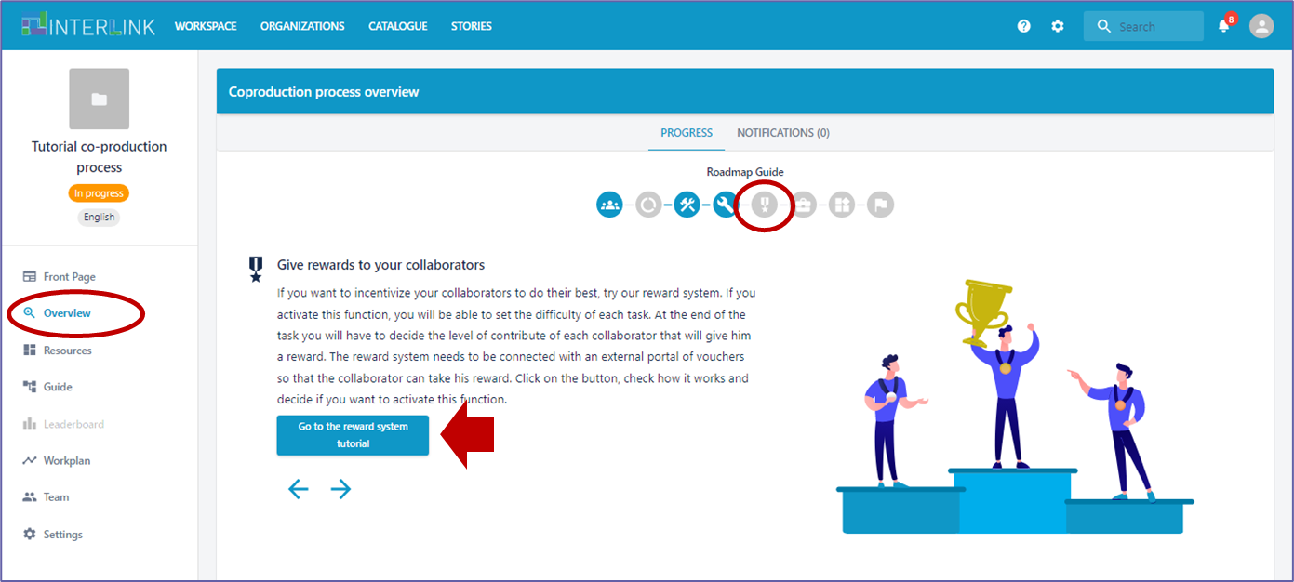

2. The option for activating / deactivating the gamification functionalities is also always available in the "Settings" section of the co-production process.

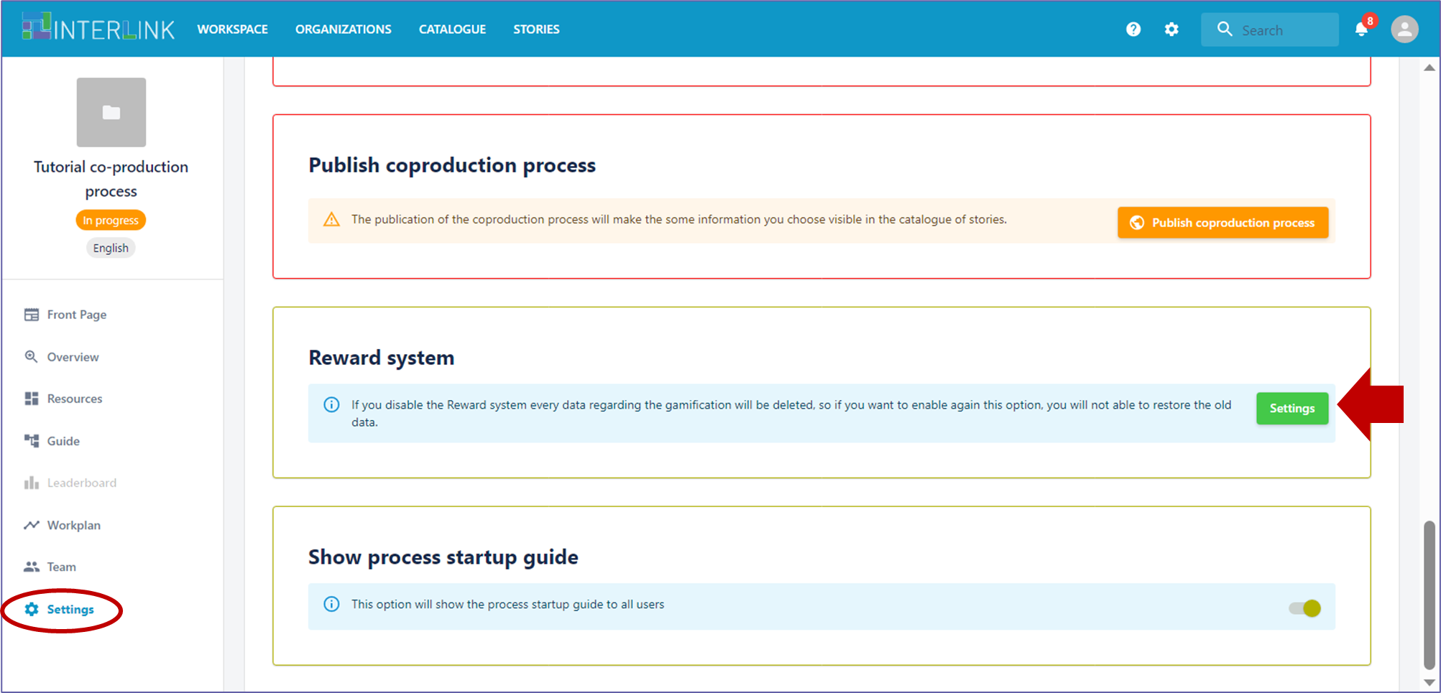

After requesting the activation of the gamification functionalities (using the methods 1. or 2. explained here above), a pop-up window appears with further information and instructions for customising the functioning of the system.

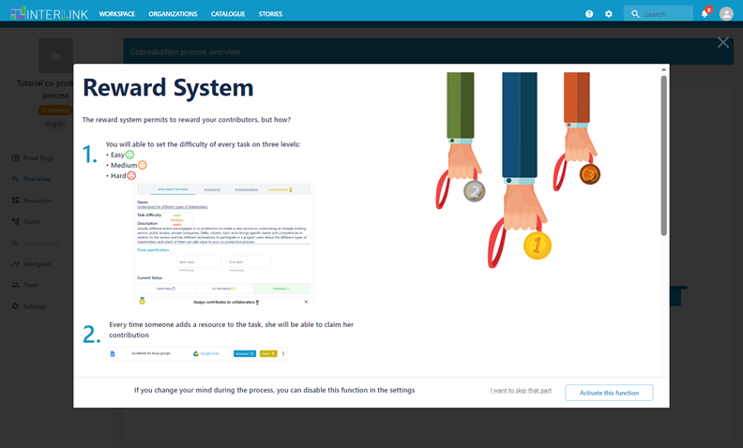

When scrolling down the instructions, you can find configuration options that allow you to choose whether a Leaderboard should be shown or not. You may wish to activate the Leaderboard if you feel a bit of competition may be beneficial to keep participants engaged.

After you have selected your preferences, you can proceed to activate the functionality.

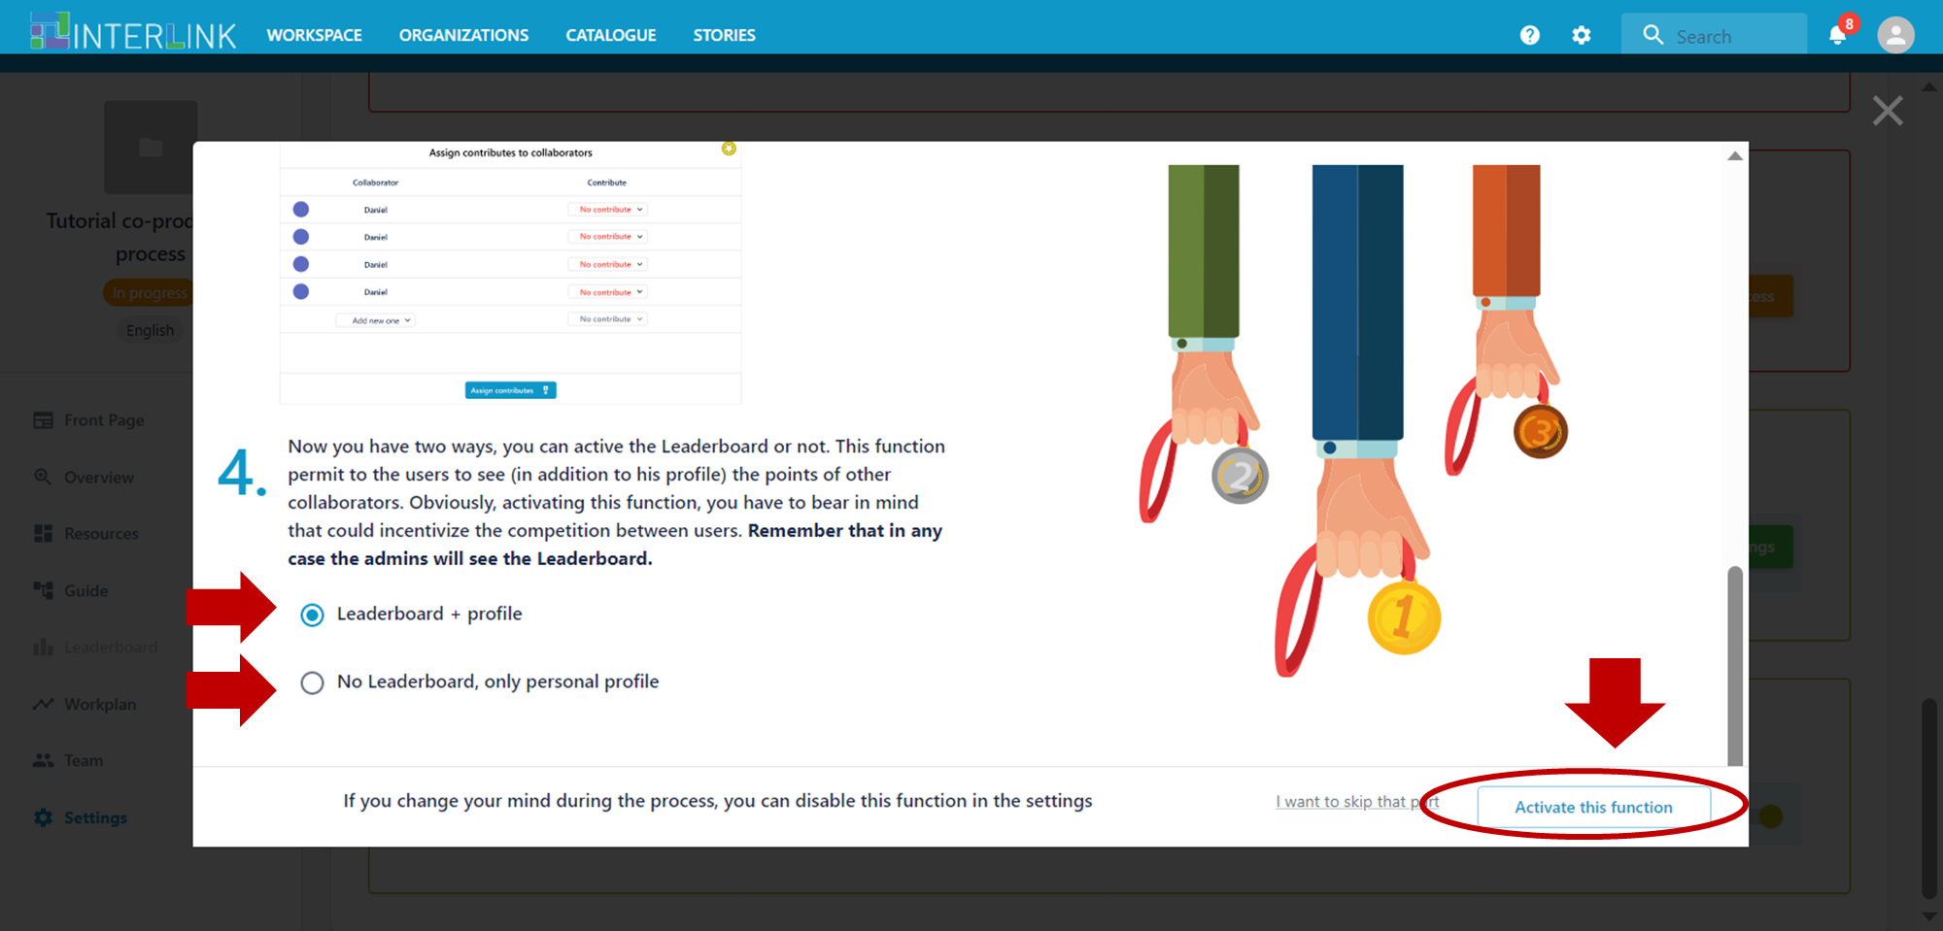

When the gamification functionality is on, this is notified by a dedicated icon underneath the name of the co-production process. If you change your mind and want to disable the gamification functionality, you can always do so from the Settings section.

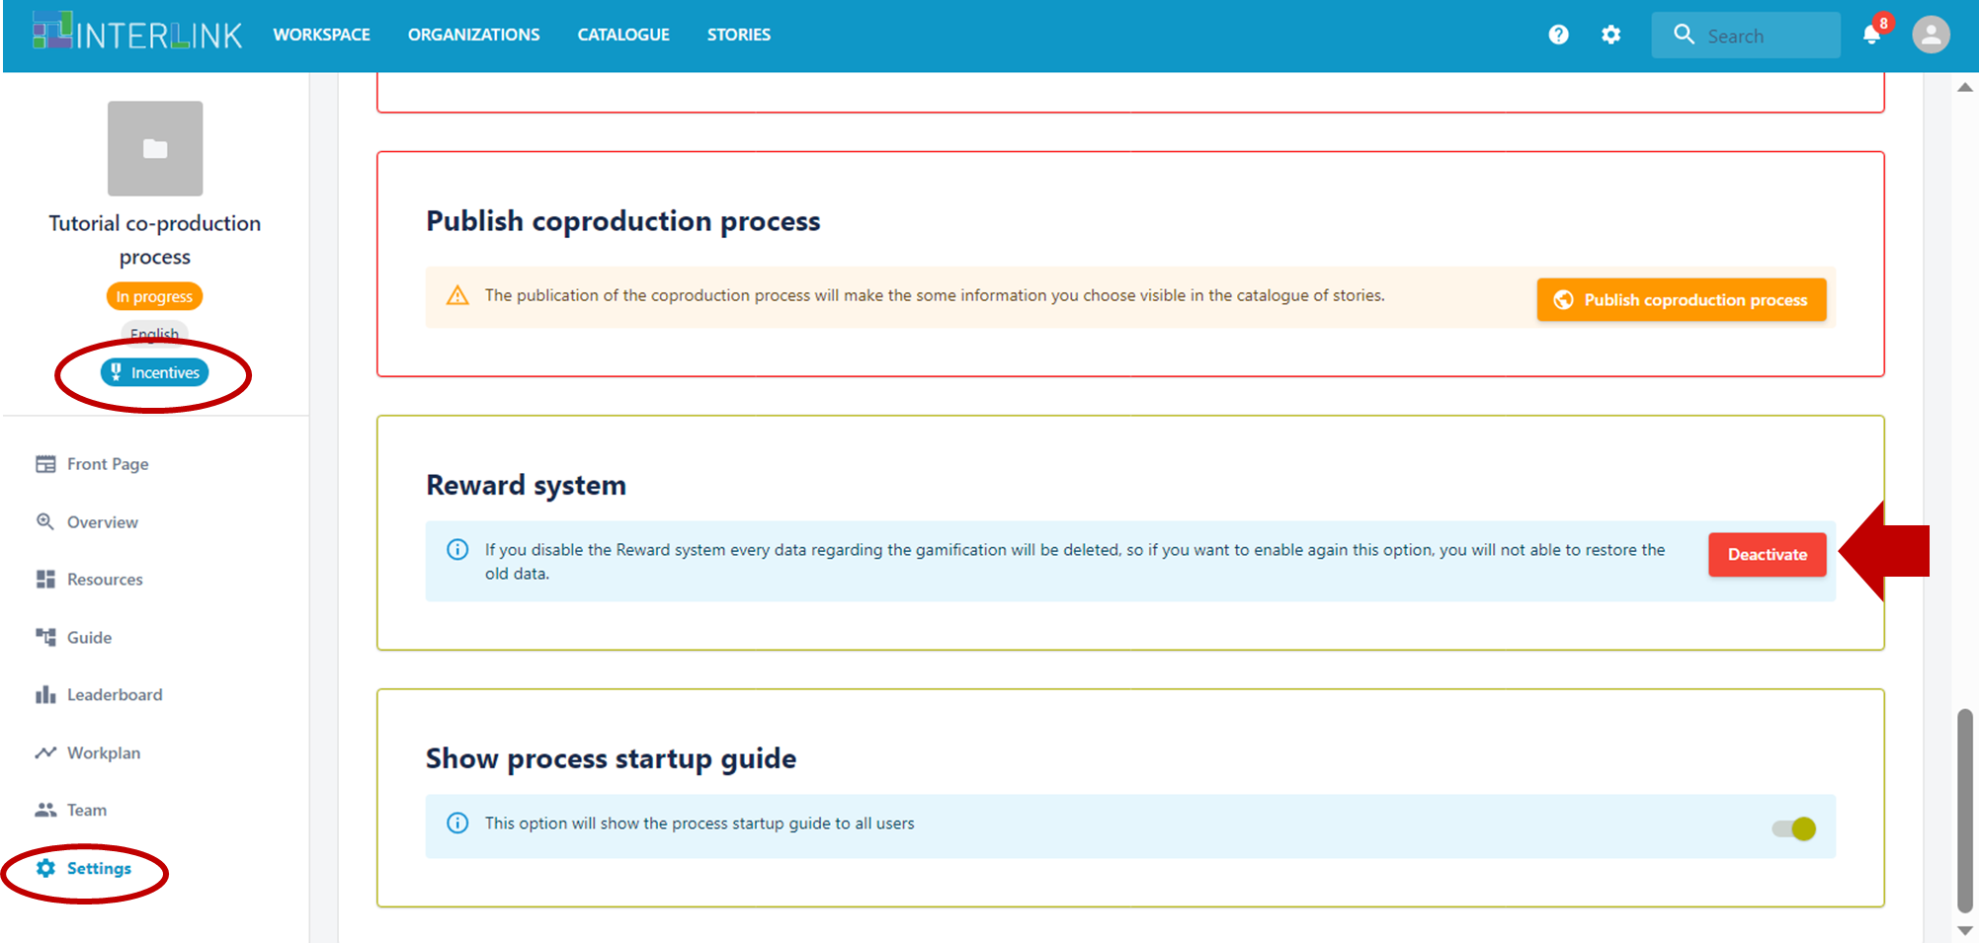

### Automatic monitoring of resource creation

Whenever a participant creates a new resource using the in-platform functionalities (for example by instantiating a knowledge INTERLINKER or by creating a new Google Drive document), the system automatically records this contribution for the user within the corresponding task. The list of actions that have been automatically recorded is visible by clicking the "Actions" button associated with each resource stored in the platform.

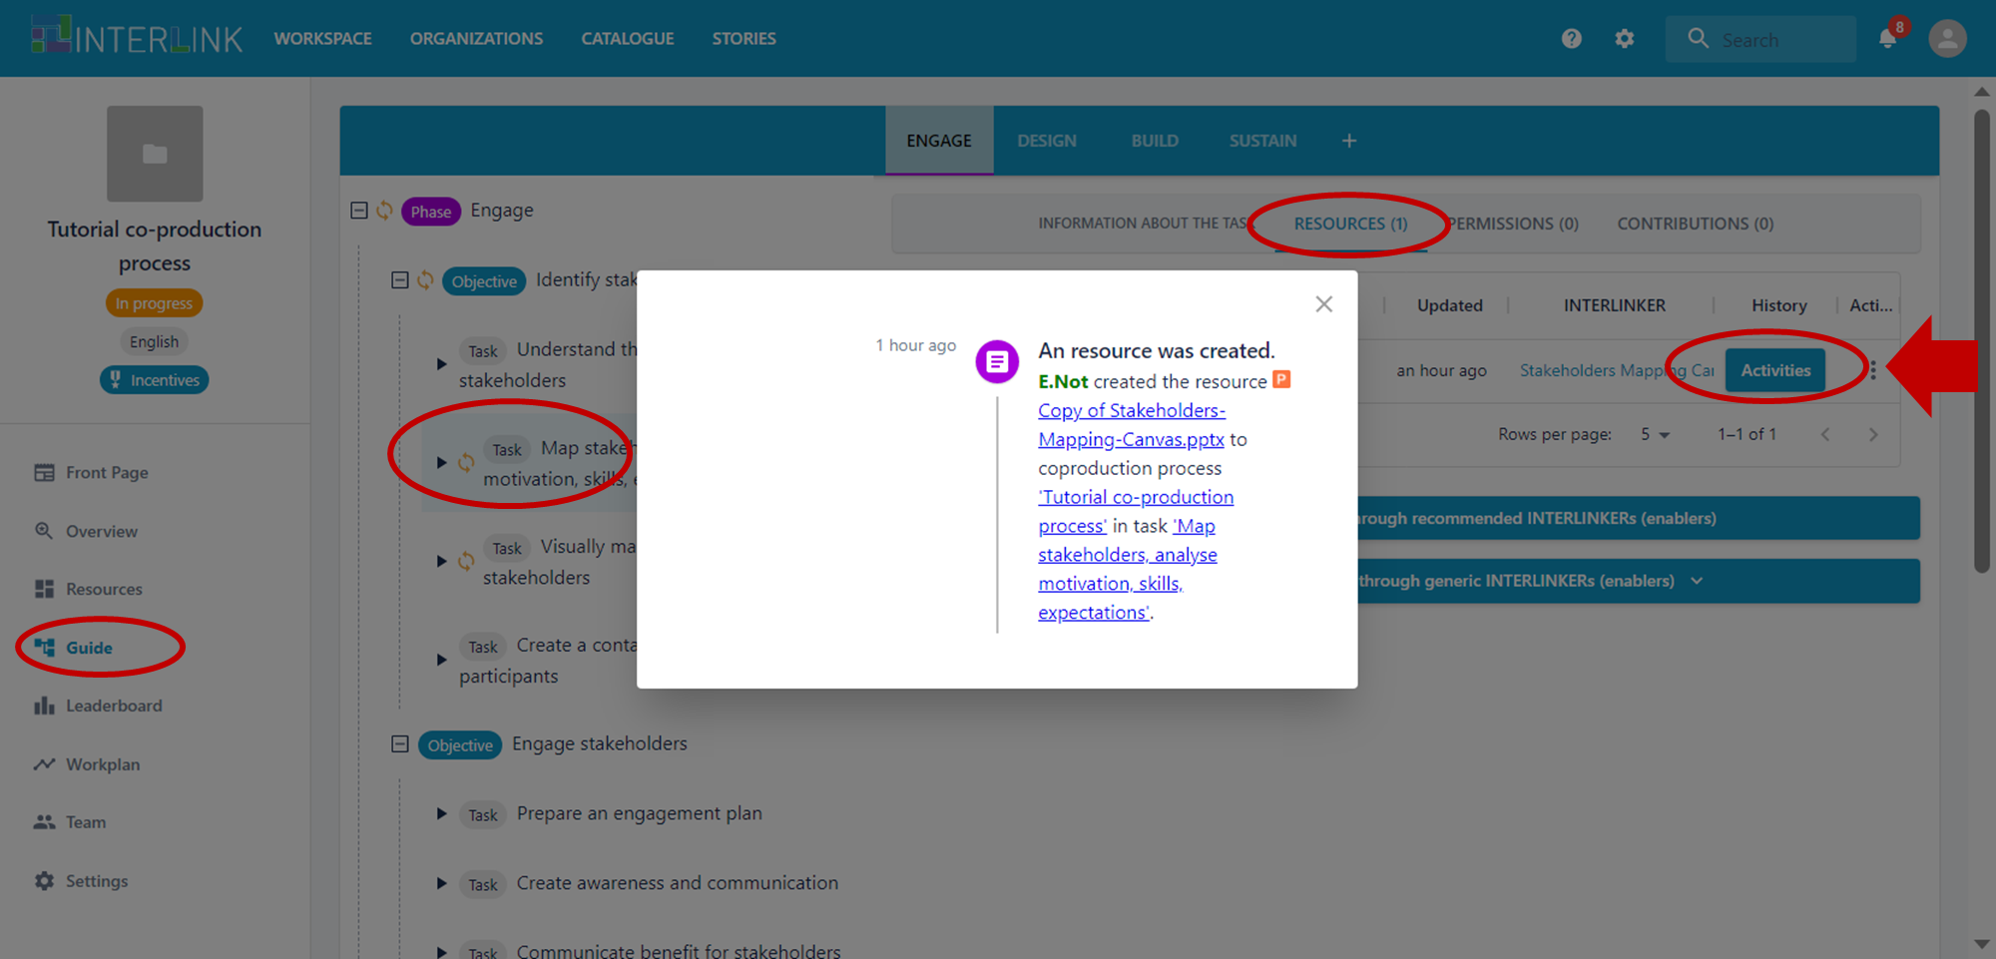

### Explicit claim of contribution by participants

Participants who have contributed to a resource, for example to edit a shared document, can declare that they have participated in the collaborative activity by explicitly claiming their contribution. This can be done by opening the Actions menu associated with a resource (identified by three vertical dots) and selecting the option "Claim".

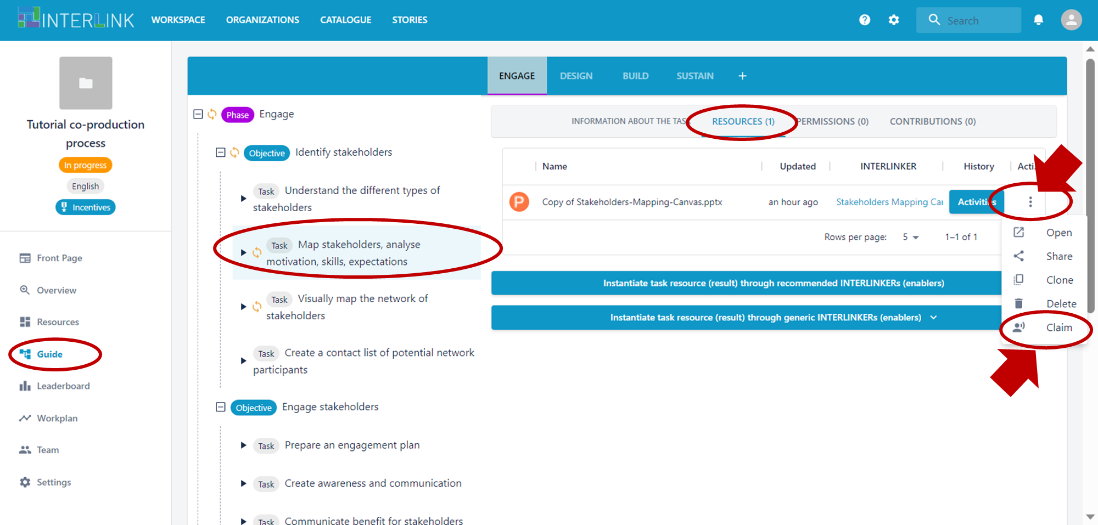

A pop-up will open where participants can briefly explain what type of contribution they provided on the resource.

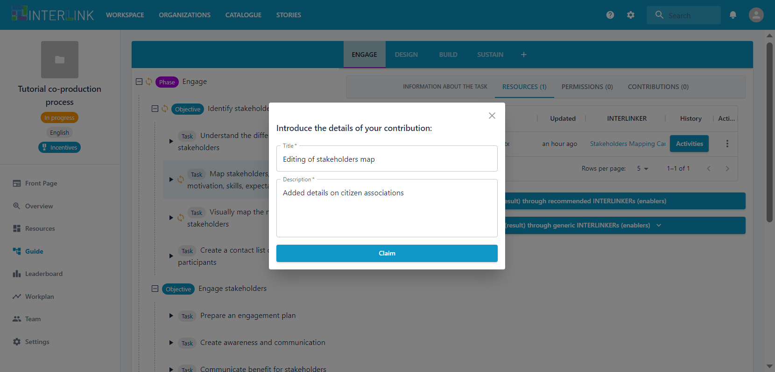

### Revision and explicit input of contributions by administrators

Administrators of a co-production process have the possibility of reviewing the claims made by participants from the "Contributions" tab available for each task.

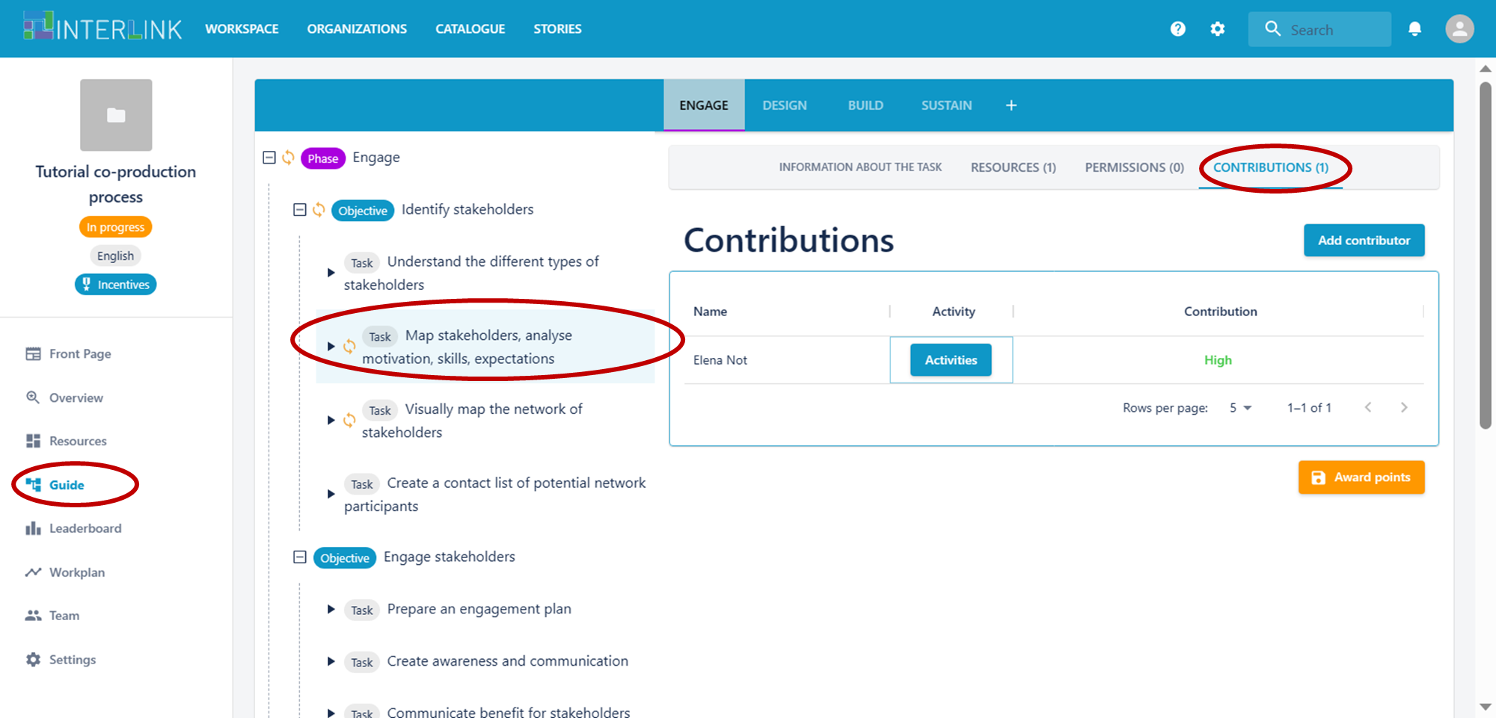

Administrators can integrate the information already populated in the system to record contributions that participants have not claimed for activities inside the Collaborative Environment, but also for other offline activities (for example, participation in meetings). This manual operation is accessible from the "Add contributor" blue button on the left. To add new contributors, the administrator can add single email addresses of registered users, entire teams or can upload a csv file containing a list of email addresses.

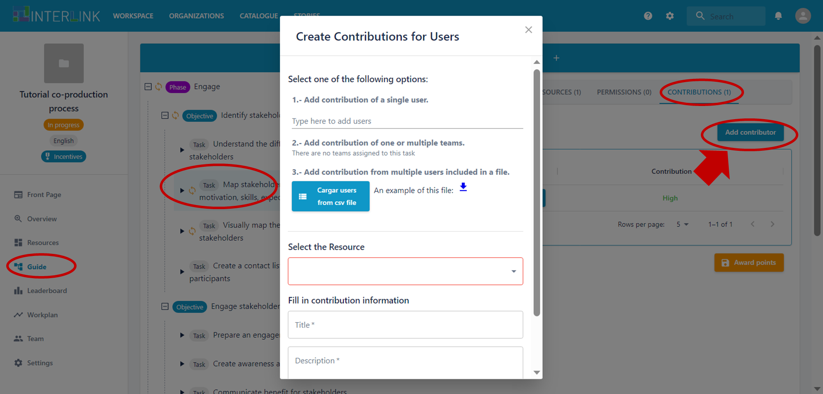

Administrators can also manually revise the level of contribution assigned to task participants. A double click on the contribution level opens a menu where different levels can be selected.

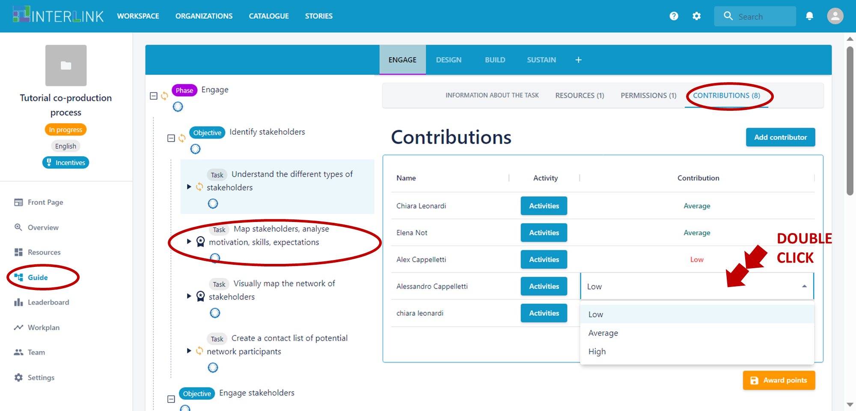

### Setting the task difficulty level

The gamification functionality is based on the recognition of participants' contribution to co-production tasks. Given that co-production tasks may be associated with very different types of problems to solve and different activities, co-production administrators might wish to identify the tasks that are more difficult to perform, and prize contributors with additional points. In the INTERLINK Collaborative Environment this is possible by adjusting the level of task difficulty in their descriptions.

When the gamification system is activated, all the tasks in the co-production schema are initially assigned an empty difficulty level. Administrators can review this value by editing the description of a task. Tasks with higher difficulty level will grant contributors more points.

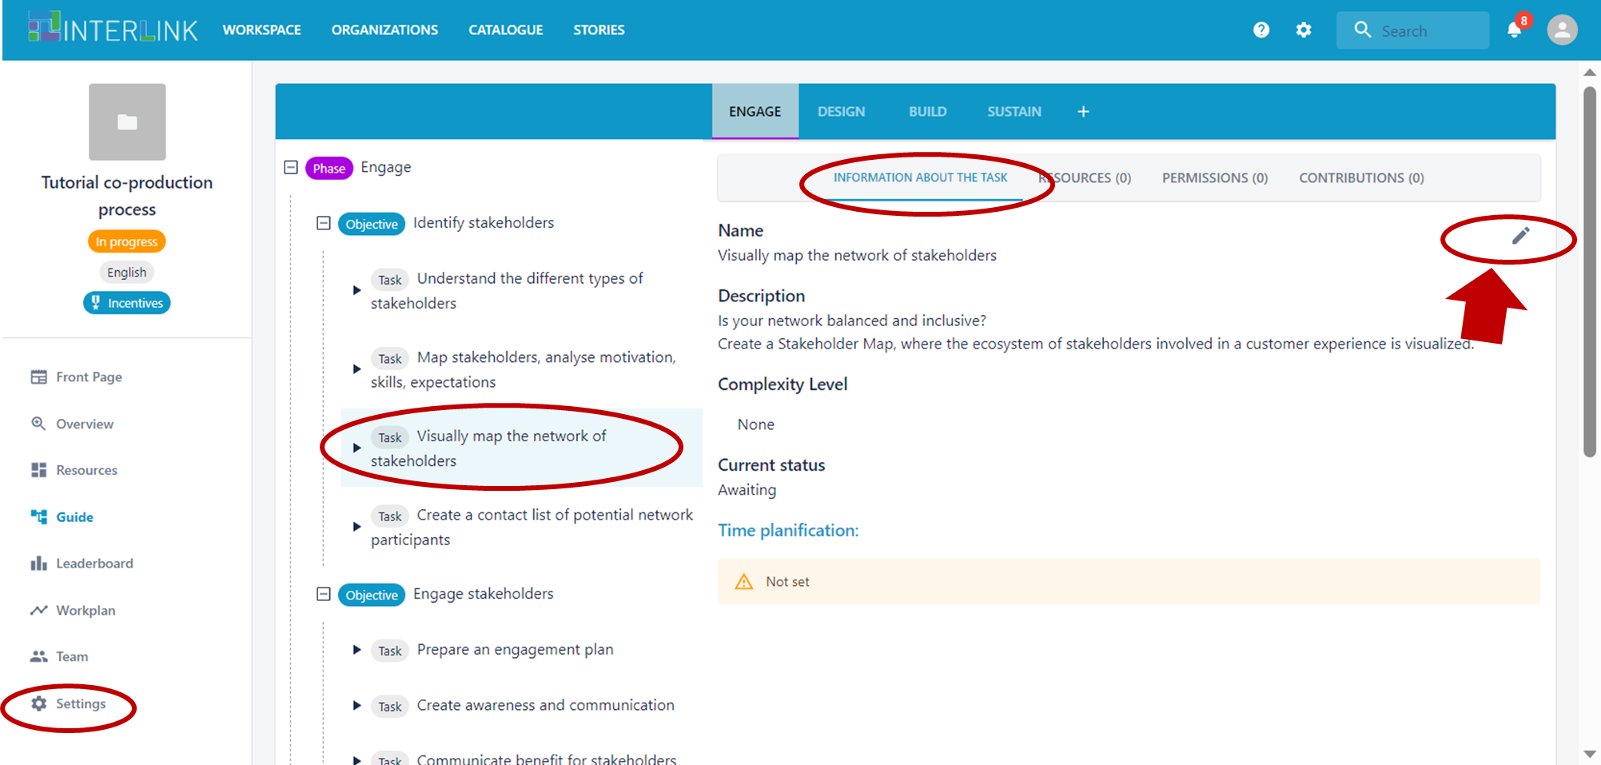

### 

### Closing a task and computing points

When all the contributions for a certain task have been recorded, the administrator can decide to close the task and compute the points that will be assigned to all contributors for their participation in the task. From the "Contributions" section of each task, an orange button "Award points" can be used for this aim. As an effect, the graphic layout of the "Contributions" section will be updated with a new view of contributors and a badge icon will appear close to the name of the task to signal the fact that points have been awarded.

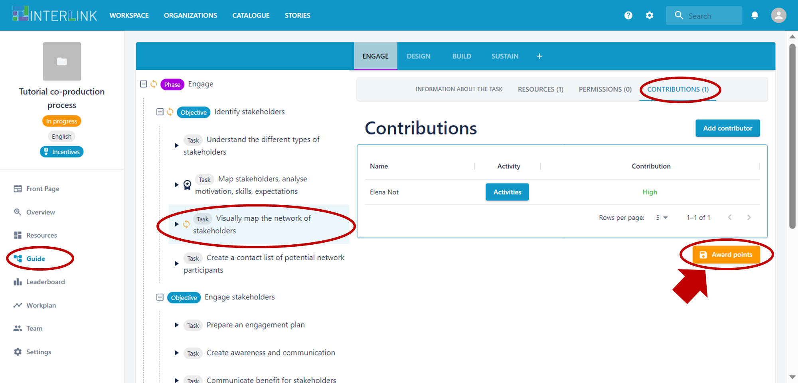

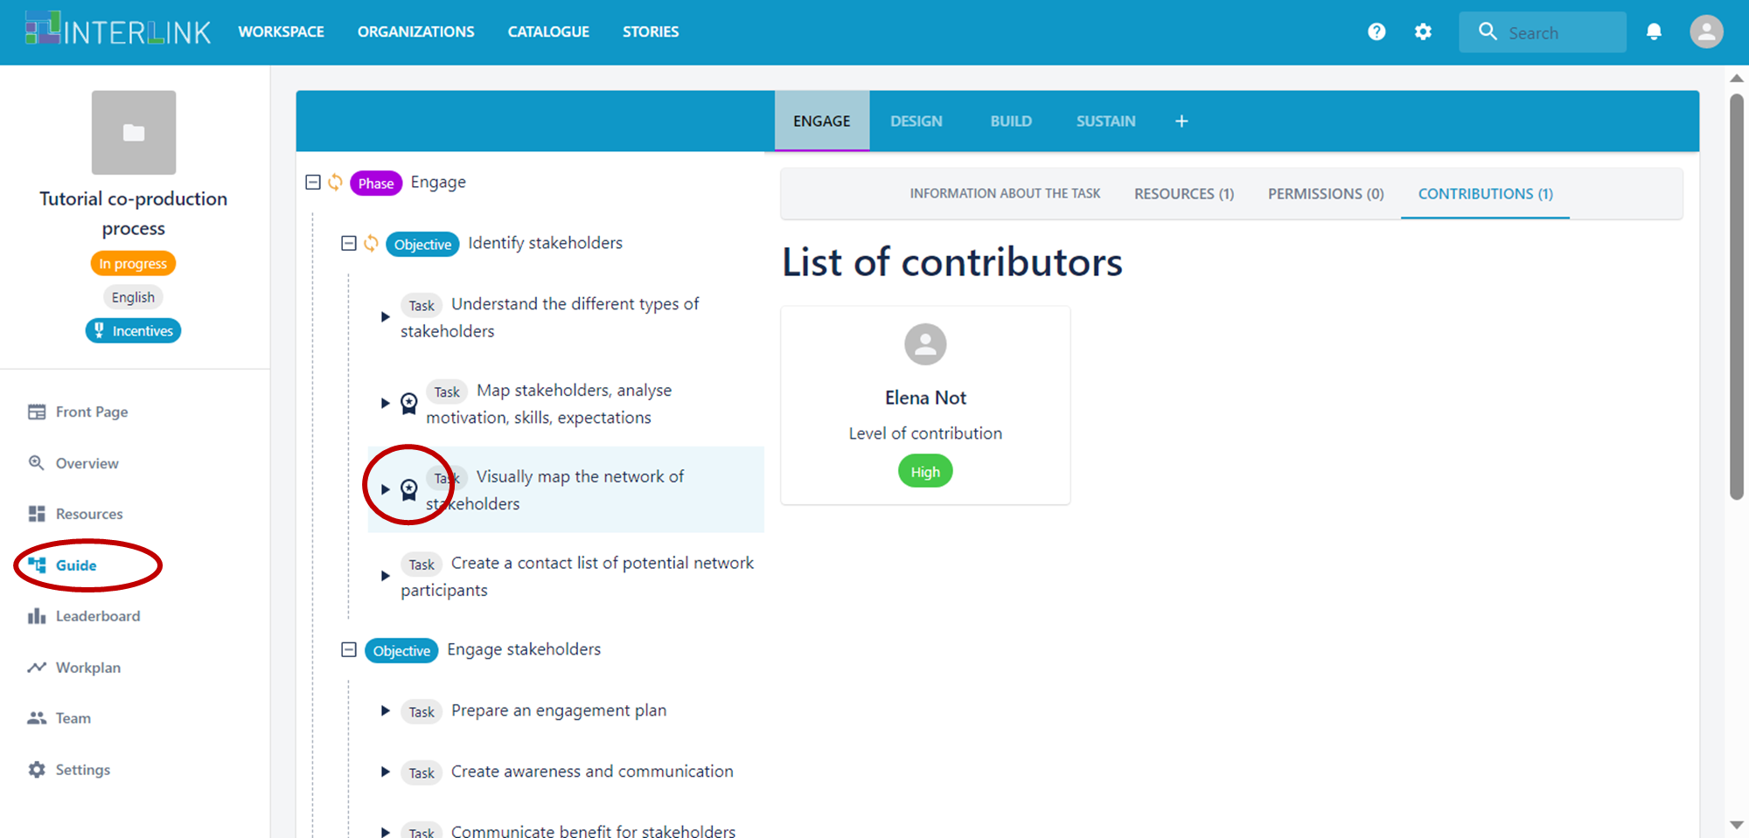

### Visualisation of personal summary of points

From the "Leaderboard" section of the interface, all participants can inspect the details of the activities that allowed them to earn points from the "My profile" tab.

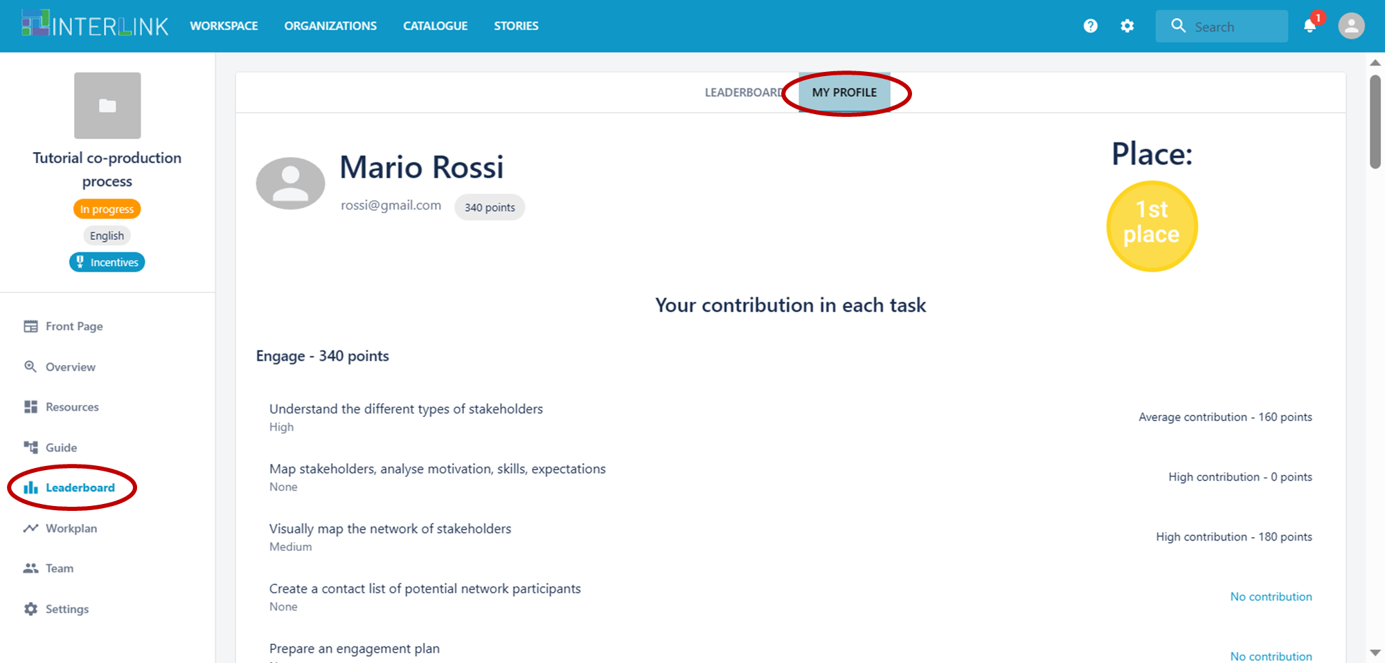

### Visualisation of group leaderboard

Should administrators have configured the gamification engine to also display a rank of all personal contributions, a Leaderboard tab is available in the "Leaderboard" section to display the overall list of points gained by all participants.

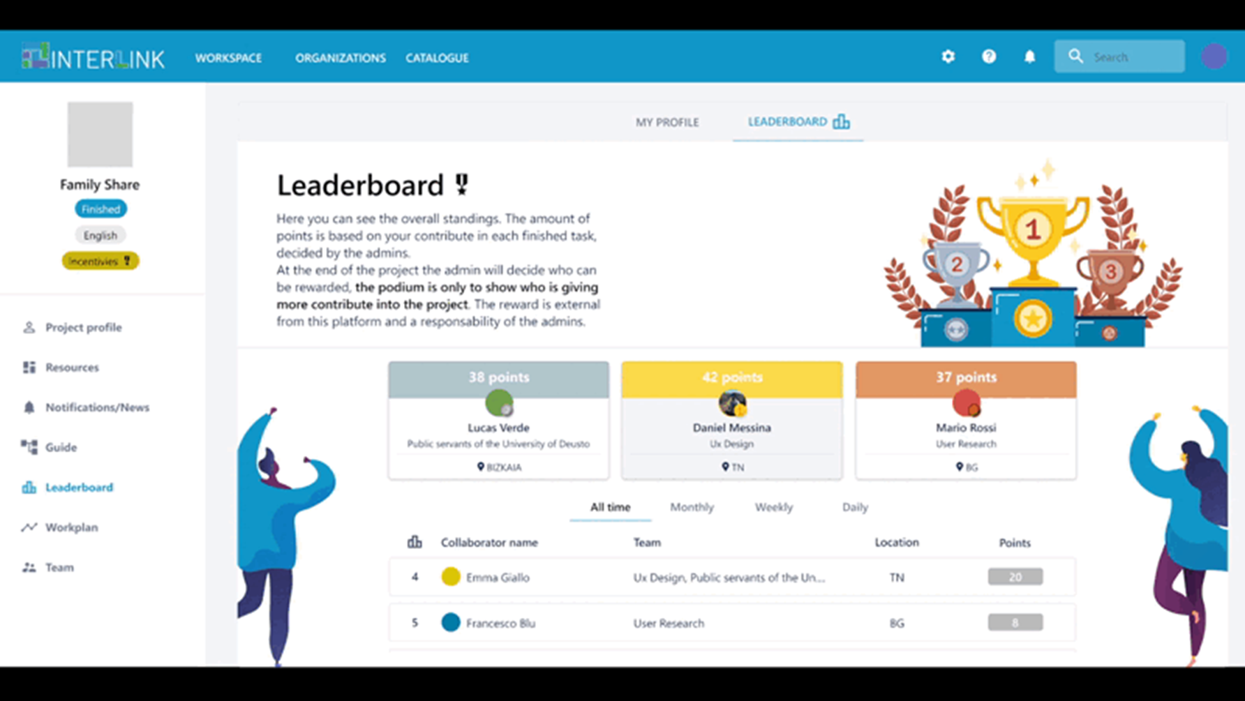

## 

## Are there INTERLINKERs that facilitate the integration of gamification functionalities in the development of public services?

The INTERLINKER catalogue includes reusable software components that may allow you to set up functionalities for extending your public services with user activity tracking, points assignment, and conversion into configured rewards.

### Gamification Engine INTERLINKER

< description in progress >

### Loyalty Module INTERLINKER

< description in progress>

This document, prepared by the [INTERLINK](https://interlink-project.eu/) European project, is licensed under a Creative Commons Attribution-ShareAlike 4.0 International licence ([CC BY-SA 4.0](https://creativecommons.org/licenses/by-sa/4.0/)).